1. Surfaces

Supercell models very handy for modeling surfaces, their structure, their energy, adsorption, reaction,…

For our models, can think of the surface as arising from cleaving a crystal (Bravais lattice) along some plane. Here’s a couple examples from the metal and oxide worlds:

FCC metal and some cleavage planes:

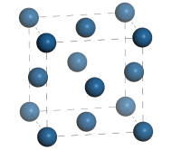

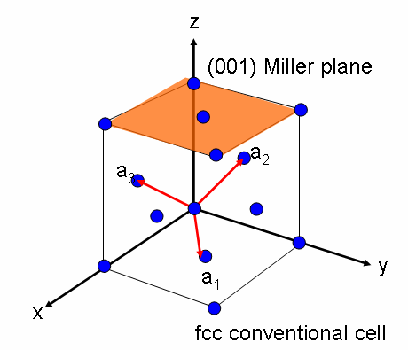



Surface planes can be described by Miller indices. Miller plane label has format (*ijk*), where the three integers give the direction of the vector perpendicular to the plane, in lattice vector coordinates. The definition thus depends on the choice of cell vectors. For FCC above, for instance, planes are described with respect to the conventional cell.

(111) termination particularly common, lowest energy for most (maybe all?) FCC metals. Gives abcabc type stacking of hexagonal layers:

Rock salt oxide:

 

Could be something like NaCl or MgO. Crystal structure contains two interpenetrating FCC lattices. Can be described using primitive FCC cell with a basis of two or as a conventional FCC with a basis of eight. Latter is shown above.



Last is an example of a polar surface; the charges on the ions alternate between positive and negative perpendicular to the plane. Typically unstable to reconstructions. Tasker has categorized ionic surfaces:

Tasker type I: individual layers are charge neutral, no dipole [MgO(001)]

Tasker type II: individual layers are charged, but groups of layers are charge neutral and non-polar [Al2O3(0001); TiO2(110)]

Tasker type III: groups of layers have net dipole [MgO(111); SrTiO3(100)]

1. Surface slab models

How to construct a supercell model of a surface? Construct a slab, infinite in two dimensions and with “vacuum” spacing between successive slabs.

 (100) slab

(103) supercell, illustrating a stepped surface: 

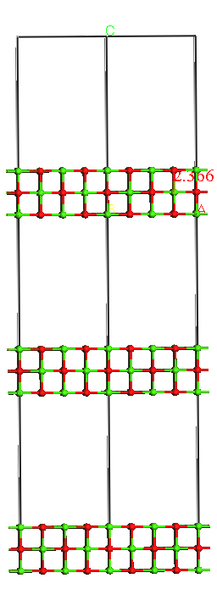 

Key parameters that describe slab model:

1. Cleavage plane
2. Thickness (number of layers) of slab
3. Thickness of “vacuum”
4. Lateral dimensions of periodic unit

Like all supercells, the slab supercell must be a Bravais lattice, and generally speaking it will be a different Bravais lattice than that of the parent crystal. For instance, parent MgO is FCC, put (001) slabs are described in orthorhombic or tetragonal cells.

Rocksalt conventional FCC cell POSCAR:

simple cubic

4.2112

1.0 0.0 0.0

0.0 1.0 0.0

0.0 0.0 1.0

4 4

direct

0.5 0.5 0.5

0.5 0. 0.

0. 0.5 0.

0. 0. 0.5

0. 0. 0.

0.5 0. 0.5

0. 0.5 0.5

0.5 0.5 0.

Two-layer-thick tetragonal (001) slab (double the c vector and halve the z fractionals):

tetragonal

4.2112

1.0 0.0 0.0

0.0 1.0 0.0

0.0 0.0 2.0

4 4

direct

0.5 0.5 0.25

0.5 0. 0.

0. 0.5 0.

0. 0. 0.25

0. 0. 0.

0.5 0. 0.25

0. 0.5 0.25

0.5 0.5 0.

Simplest case possible. In general, cell axes may need to rotate from bulk to slab, will want to vary slab thickness, vacuum….

FCC metal surfaces:

 

Example of a √3×√3, 3 layer (111) slab:

(111) FCC slab, three layers thick

4.8057764

.8660254037839999 -.5000000000000000 .0000000000000000

.0000000000000000 1.0000000000000000 .0000000000000000

.0000000000000000 .0000000000000000 3.0

9

Direct

0.000000000000000 0.0000000000000000 0.0000000000000000

0.666666666666666 0.3333333333333333 0.0000000000000000

0.333333333333333 0.6666666666666666 0.0000000000000000

0.333333333333333 0.3333333333333333 0.1666666666666667

0.000000000000000 0.6666666666666666 0.1666666666666667

0.666666666666666 0.9999990000000000 0.1666666666666667

0.666666666666666 0.6666666666666666 0.3333333333333333

0.333333333333333 0.0000000000000000 0.3333333333333333

0.000000000000000 0.3333333333333333 0.3333333333333333

1. Surface energy

How to do a calculation on a slab? One common question to address is the surface energy, i.e. energy to generate surfaces from bulk, energy/area (always a positive quantity, or material is unstable!!!). Will differ from surface plane to surface plane.



Because this involves comparing energy from supercells of different shapes and sizes, particular care has to be taken use equivalent lattice constants, computational parameters, energy cutoffs, and **k** point samples. Results can of course depend on thickness of slab and vacuum. Typically look for convergence with respect to this. Remember, the size of the plane wave basis scales with the box size, so more vacuum will be computationally more expensive.

**k** point sampling need only be down in the plane of the slab; the interactions between slabs is (or should be!) negligibly small, and the results should be insensitive to the k points in the vacuum direction. In general set number of k points in that direction to 1. Typical KPOINT file format, appropriate for an oxide slab like that above:

2x2x1 surface KPOINT file

0

Monkhorst-Pack

2 2 1

0. 0. 0.

Conventional MgO (4 formula units): -48.756 eV

2 layer (100) slab (4 formula units): -46.663 eV

area 2 sides * (4.2112 Å)2 = 17.7342 Å2

Surface energy: 0.11 eV/Å2 = 1.9 J/m2.

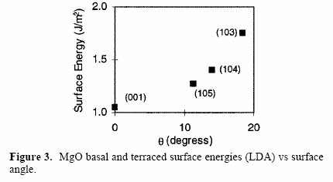

Some well-converged results (see W. F. Schneider, J. Li, and K. C. Hass, “Combined Computational and Experimental Investigation of SOx Adsorption on MgO,” *J. Phys. Chem. B*, **2001**, *105*, 6972–6979):

What’s missing in our calculation? Slab is too thin, and we did not allow the surface to relax!



Common practice is to fix one side of the slab at the bulk positions and relax the other. Have to use “Selective Dynamics” in POSCAR. Rationale is that “fixed” side replicates constraints that would be imposed by a truly semi-infinitely deep slab. Defensible for metals, no worries for rock salt, but can be problematic in other cases, especially non-type-I surfaces, where unrelaxed surface can leave unphysical dangling states.

For polar surface, dipole corrections (LDIPOL) can be important to get reasonable energies. Places a charge sheet in the vacuum that compensates the dipole generated by an adsorbate, magnitude calculated self-consistently. Most important in highly dipolar situations.

1. Surface potentials and Fermi energies

Calculations give distribution of charge in and near surface. Recall that in a supercell calculation the absolute electrostatic potential is not well defined, so the absolute eigenvalues are not meaningful. One of the advantages of having a vacuum space in the cell is that it provides a reference potential for the vacuum, i.e., if we make the vacuum spacing “thick enough” to be truly vacuum, can set the electrostatic potential in that region to zero and use that offset to reference the band energies and Fermi energy to. Set LVTOT=.TRUE., prints LOCPOT file which contains the local potential energy on a grid filling the supercell. Have to plot, average in plane.

Example of Ni(111) surface from Vasp hands-on:



From Pt(111) calculation, LOCPOT slice and plane-averaged potential:

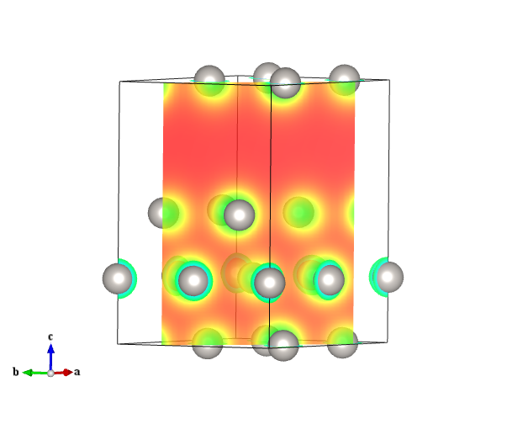

1. Surface adsorption

Often interested in how strongly an adsorbate binds at a surface. Figured out using geometry optimizations, as we’ve seen many times before. Challenge is that adsorption geometries can be hard to predict; optimizations can be time consuming.

Adsorption on oxides

Show example of adding O to our MgO slab above. SO2 on MgO another example. Would first calculate SO2 in a vacuum, then add to surface and relax. (At least) two types of adsorbate geometries found:



Calculate adsorption energy *E*ads = *E*slab+ads – *E*slab – *E*ads. Note this convention makes adsorption exothermic; opposite convention is also common. Lateral dimensions can matter a lot; too small a cell and adsorbates will feel the influence of their neighbors, altering adsorption energies. Example above is a c(2×2) cell, with 16 atoms per slab. Typically would test for sensitivity to cell dimensions.

How to analyze adsorption?

* Site-projected DOS
* Charge density difference: ∆*ρ* = CHGCARslab+ads – CHGCARslab – CHGCARads. Utilities available to calculate this difference. Must be done at constant atom positions.
* Can calculate vibrational spectra of adsorbates using Selective Dynamics.

Adsorption on metals

Metal surfaces can present a number of adsorption site types. Consider (111) surface:



Compare adsorption of an O atom in each location, on Pt(111):



O prefers FCC site. Could use binding energy to calculate a Langmuir adsorption isotherm, for instance.

DFT is generally pretty reliable for calculating adsorption site preferences; adsorption energies have the typical errors of the GGA. CO on Pt is a notable exception; the GGA infamously predicts CO to prefer FCC sites, where they bind to three surface Pt; reality is atop Pt. Consequence of GGA overestimating the importance of π backbonding.

1. Coverage-dependent adsorption

Surface adsorbates can interact with (attract or repel) one another, and this can have an effect on adsorption energies, isotherms, saturation coverages. Representative O–O interactions on Pt(111):



Formation energy a common way to compare these:



Some sample surface configurations:

Generate lots of these, plot of formation energies vs. composition shows which arrangements are stable, those that lie along lowest “convex hull.”



Slope of this curve gives 0 K binding energy per adsorbate. Binding energy is not a single number, but varies with coverage. Note at 2/3 coverage, binding energy goes to 0; highest coverage accessible with O2. To calculate isotherms can either create interaction model and simulate with Monte Carlo, or can “discretize,” estimate from slopes chemical potential ranges that each configuration is stable:



Plot of *γ* vs. *μ* gives a set of lines with slopes of *N*ads; stability ranges are ranges that given line are lowest:



For O2, for instance, have 

1. Reaction Barriers

Can calculate transition states for surface reactions, e.g. to parameterize kinetic models. Simple example, adsorbate diffusion on a surface, can guess TS and calculate energy and partition functions.

For more complicated cases, “nudged elastic band” methods are popular. Don’t require knowledge of Hessian, just require initial and final states and some (pretty good!) guess of intermediate “states” or beads. Algorithm works by putting springs between adjacent beads that supplement the true forces and keep the beads separate. Relaxation under combination of true and spring forces causes beads to move to minimum energy surface.

Example of O2 dissociation on Pt(111):





From Rachel Getman:

Elastic Band Methods for finding the MEP between two minima on a PES

* Class of methods deriving from the “chain-of-states” method that finds MEP between two minima using the gradient of the PES but not the Hessian
  + Does not require “good” estimate of MEP/TS geometries
* Method:
  + Locate minima on PES
  + Draw a path between them
    - Most common way to do this: linear interpolation
  + Discretize the path into a finite # of points (called “images”)
    - Each geometry is a linear interpolation of the two minima
    - Optimization is performed at each point by analyzing the forces on the geometry. Goal is to converge each image to the same MEP.
* What is the MEP? On the MEP, the forces along the direction parallel to the reaction pathway are finite, but they are 0 in all other directions

E

F:

rxn coordinate

* Complex surfaces contain many reaction pathways and thus many MEPs. We want to make sure we converge all images to the same MEP, so we connect them with a theoretical spring:

I

1

2

3

4

F

x

* + Spring force on each image is: 
* Since we want to converge to the MEP and not necessarily to a stationary point, we need to project the component of the total force perpendicular to the reaction pathway out of the total force:
  + 
  + This way, the reaction path is updated @ each step (or every 10 steps, or …, depends on program, defaults, user inputs, etc.)
  + Elastic Band method is converged when  = 0 (or goes below some specified convergence criterion.)
    - If all spring constants are the same, the spring force is minimized when images are equally spaced
    - Perpendicular component of the molecular force zero-ed when image is on the MEP
* Relaxation in the direction perpendicular to the reaction path stretches images over the PES, much like pulling a rubber band over a surface (hence “Elastic Band” Method)
* Nudged Elastic Band method:
  + Removes perpendicular component of spring force:
  + 
  + This way, spring forces do not interfere with relaxation to MEP
    - Takes away unnatural forces perpendicular to the reaction path
    - This clean version of the EB force brings about an optimization algorithm referred to as “nudging,” hence “Nudged” Elastic Band
* EB methods do not necessarily find the “TS”
  + Sometimes require interpolation between the two highest energy images
* Cure: Climbing Image Elastic Band Methods
  + After a few geometry convergence steps in the EB method, locates image with the highest E
    - This image is now denoted MAX
  + Spring forces are removed from max, CI-NEB force becomes:
    - 
    - MAX moves down toward MEP and up to TS
    - Upward movement denoted “climbing,” hence “Climbing Image”-Nudged Elastic Band

Relevant literature:

* Plain Elastic Band of Elber and Karplus: Chem. Phys. Lett., 139, 1987, 375.
  + No projection of forces: PEB force is a sum of spring and total molecular forces.
* Elastic Band Method of Ulitsky and Elber: J. Chem. Phys. Lett., 92, 1990, 15.
  + Projects out parallel component of molecular force
* Self-Penalizing Walk method of Czerminski and Elber: International Journal of Quantum Chemistry: Quantum Chemistry Symposium 24, 1990, 167.
  + Instead of a spring force uses a repulsive force and an attractive force couple to maintain connection but not allow images to get too close. Projects out parallel component of molecular force.
* Locally-Updated Plains method of Choi and Elber: J. Chem. Phys., 94, 1990, 751.
  + No spring force, i.e. images are not connected. Parallel component of molecular force is projected out.
* Plain Elastic Band method of Gillian and Wilson: J. Chem. Phys., 97, 1992, 3.
  + For molecular dynamics.
* Nudged Elastic Band Method of Jónsson, Mills, and Jacobsen:
  + Projects out parallel component of molecular force and perpendicular component of spring force.
* Improved Tangent Nudged Elastic Band Method of Henkelman and Jónsson: J. Chem. Phys., 113, 2000, 9978.
  + Improves how the reaction path is calculated: 
  + Ensures equi-spacing even in regions of large curvature, gets rid of “kinkiness” of path
* Climbing Image Nudged Elastic Band Method of Henkelman, Uberuaga, and Jónsson: J. Chem. Phys., 113, 2000, 9901.
  + Introduces climbing image: spring forces removed from NEB force of image with highest energy so that it can move along the elastic band in search of the maximum. Searches to minimize total molecular force.